## **Development of a Password Generator with Tkinter GUI**

### **1. Introduction**

The internship project involved the development of a password generator application with a Graphical User Interface (GUI) using Tkinter, a Python library. This report outlines the objectives, background, software and hardware requirements, coding implementation, future scope, and conclusions of the project.

### **2. Objective**

The primary objective of this internship project was to create a user-friendly password generator application that can generate secure passwords based on user-defined criteria. Specifically, the objectives were:Develop a GUI application using Tkinter for user interaction.

* Implement a password generation algorithm to create secure passwords.
* Enable customization of password criteria such as the number of capital letters, small letters, symbols, and numbers.
* Ensure the generated passwords are strong and random.

### **3. Background**

In today's digital age, the importance of secure passwords cannot be overstated. With the increasing number of online accounts and cyber threats, individuals and organizations need robust password management solutions to safeguard their sensitive information. Password generators play a crucial role in this regard by generating strong and unique passwords that are difficult to crack.

### **4. Software and Hardware Requirements**

### Software Requirements:

* Python (version 3.x)
* Tkinter library
* Integrated Development Environment (IDE) such as PyCharm, Visual Studio Code, or Jupyter Notebook

#### 

#### Hardware Requirements:

* Computer or laptop
* Sufficient RAM and processing power to run Python scripts efficiently

### **5. Coding Implementation**

The coding implementation involved several key steps:

* Importing the required libraries (random, tkinter)
* Defining lists for capital letters, small letters, symbols, and numbers
* Creating functions to generate passwords based on user input
* Developing a Tkinter-based GUI for user interaction
* Integrating the password generation algorithm with the GUI
* Testing the application for functionality and usability
* 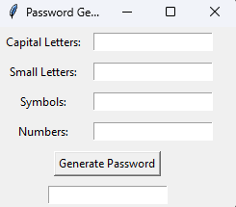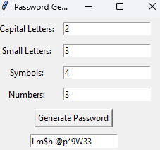

### **6. Future Scope**

The password generator application developed during this internship project lays the foundation for future enhancements and extensions. Some potential areas for future development include:

* Implementing additional features such as password strength meter, password length customization, and password saving functionality.
* Enhancing the GUI design for better aesthetics and user experience.
* Adding support for multiple languages and character sets to cater to diverse user preferences.
* Integrating the application with password management tools and cloud storage services for seamless password management.

### 

### 

### **7. Conclusion**

In conclusion, the internship project successfully achieved its objectives of developing a password generator application with a Tkinter GUI. The application provides a simple yet effective solution for generating strong and secure passwords, thereby enhancing cybersecurity for users. By leveraging Python and Tkinter, the project demonstrates the power of open-source technologies in addressing real-world challenges. Moving forward, the project holds promising potential for further innovation and adaptation to meet evolving security needs in the digital landscape.